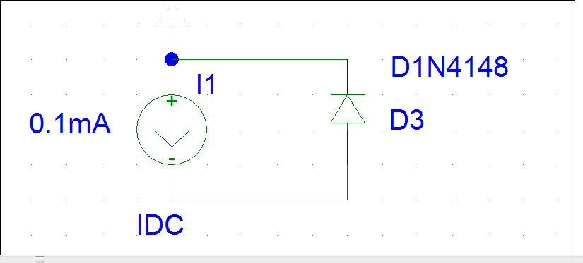
 | 0.1mA | 0.2mA | 0.5mA | 1mA | 2mA | 5mA | 10mA | 20mA
D1 | 0.45 | 0.53 | 0.57 | 0.6 | 0.63 | 0.681 | 0.72 | 0.78
D2 | 0.009 | 0.016 | 0.036 | 0.057 | 0.087 | 0.13 | 0.166 | 0.21
D3 | 0.176 | 0.195 | 0.217 | 0.231 | 0.25 | 0.274 | 0.295 | 0.316
D4 | 0.675
LED R | 1.563 | 1.591 | 1.638 | 1.668 | 1.709 | 1.777 | 1.851 | 1.969
LED G | 1.77 | 1.793 | 1.835 | 1.864 | 1.905 | 1.979 | 2.066 | 2.206
LED B | 3.1 | 3.2 | 3.3 | 3.36 | 3.5 | 3.67 | 3.86 | 4.2

